Entregable ED JavaDoc

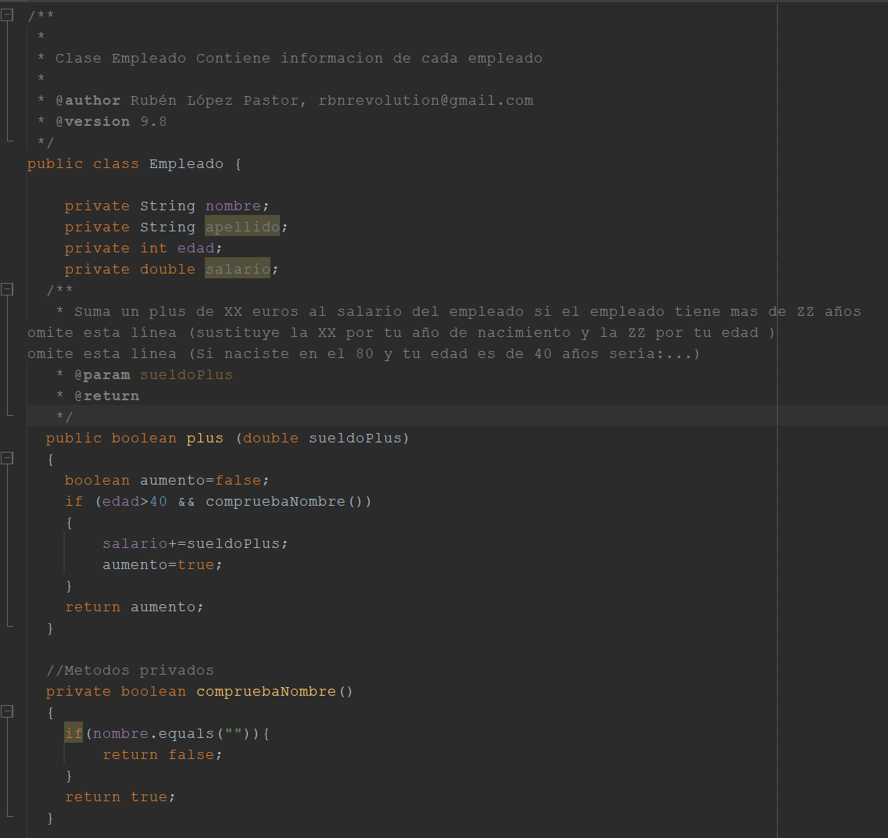

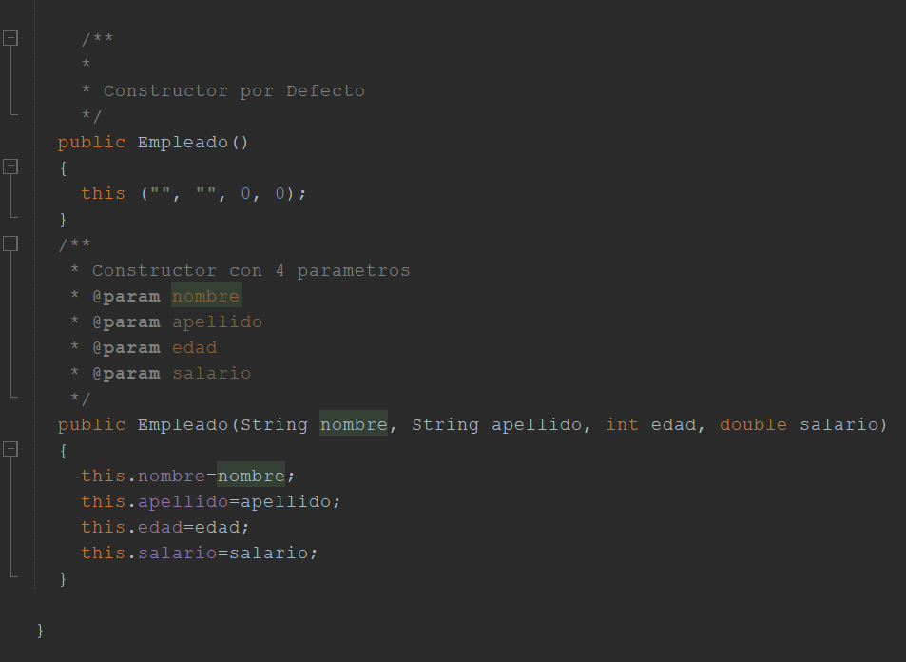

<https://github.com/lpxrevolution/06_EMPLEADO_JAVADOC>

https://rubenlopezjavadoc.netlify.app/